## ****For Your Current Tasks:****

1. **MySQL commands**: Run from any folder, but SQL executes inside MySQL
2. **Backend server**: Run from Capstone/backend/ folder
3. **Frontend server**: Run from Capstone/frontend/ai-lms/client/ folder

So for your database tasks, you can open Terminal from anywhere and run mysql -u root -p, then 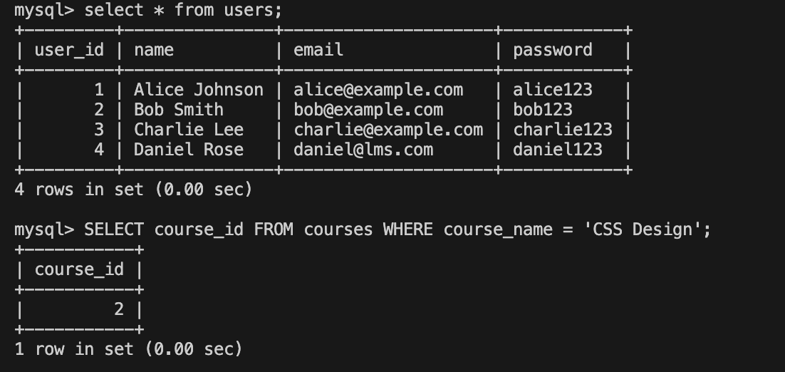execute all the SQL commands inside MySQL! 🐬

Enroll

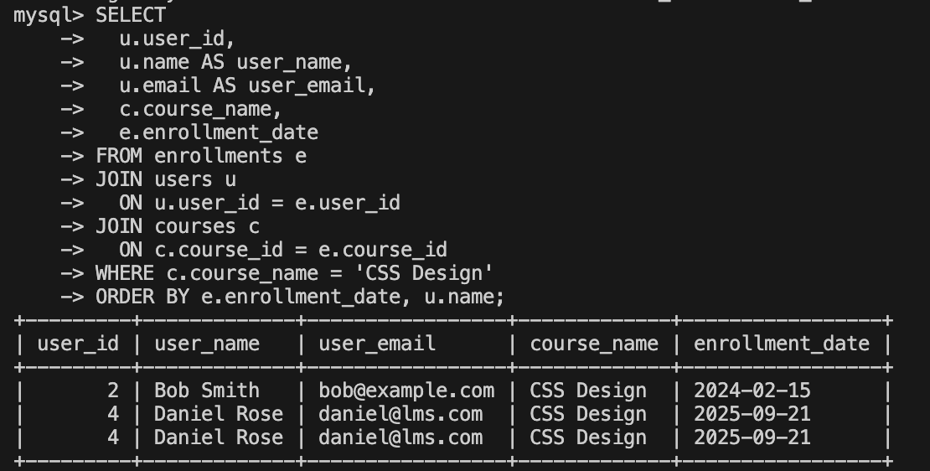

CRUD exmaples

REad

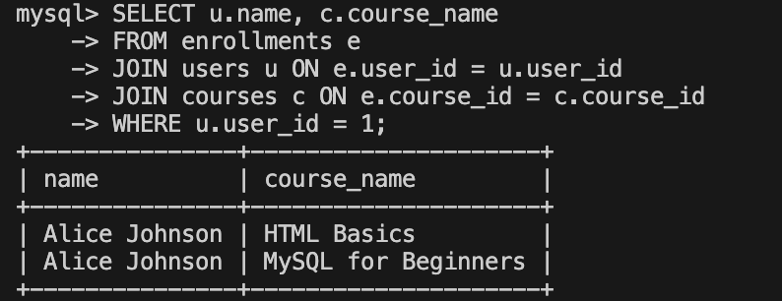

Update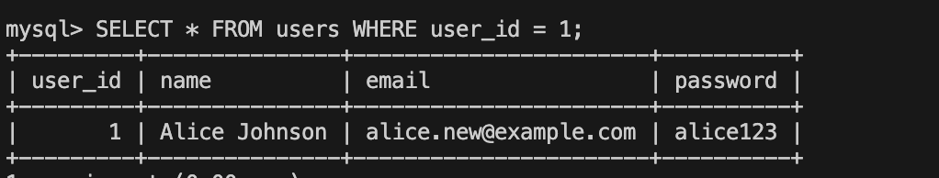

Delete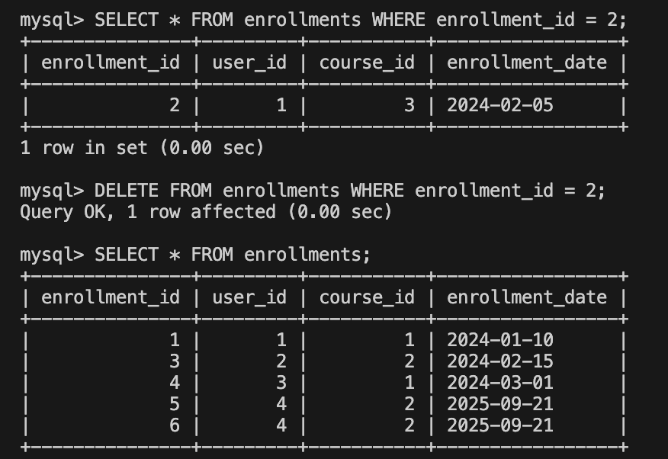

Display all users enrolled in CSS 